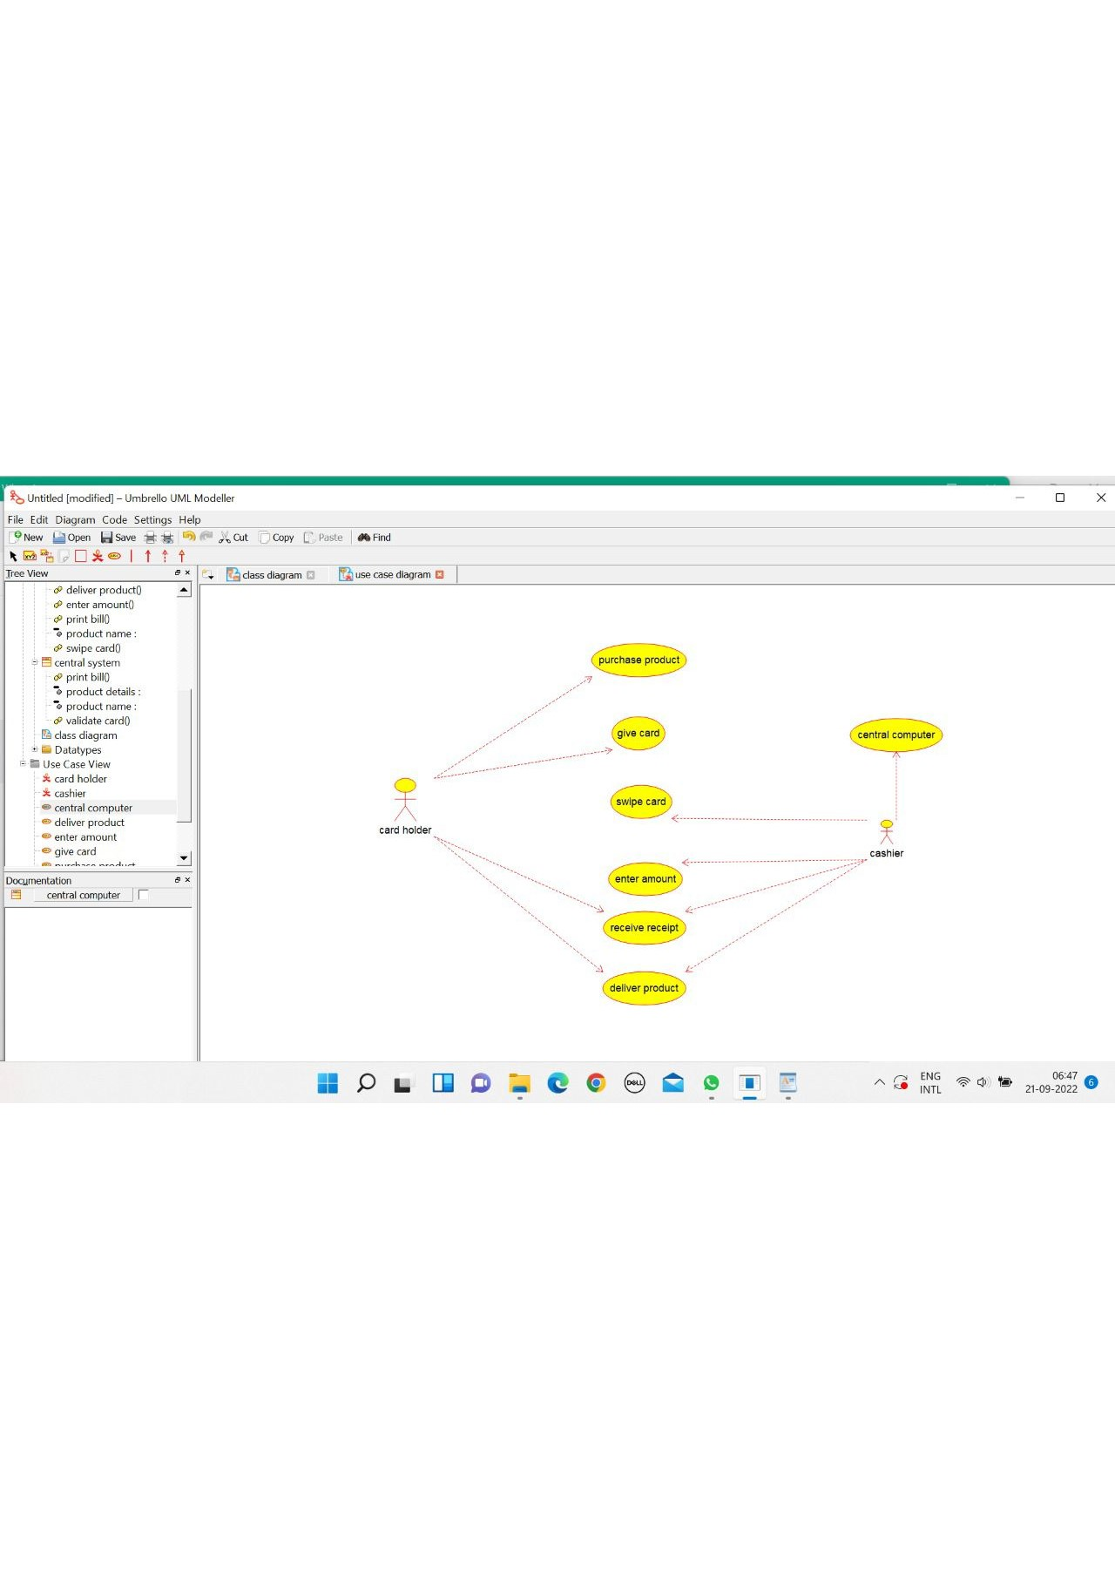

CENTRAL SYSTEM

/**

* Class central_system

*/

public class central_system {

//

// Fields

//

private void product_name;

private void product_details;

//

// Constructors

//

public central_system () { };

//

// Methods

//

//

// Accessor methods

//

/**

* Set the value of product_name

* @param newVar the new value of product_name

*/

private void setProduct_name (void newVar) {

product_name = newVar;

}

/**

* Get the value of product_name

* @return the value of product_name

*/

private void getProduct_name () {

return product_name;

}

/**

* Set the value of product_details

* @param newVar the new value of product_details

*/

private void setProduct_details (void newVar) {

product_details = newVar;

}

/**

* Get the value of product_details

* @return the value of product_details

*/

private void getProduct_details () {

return product_details;

}

//

// Other methods

//

/**

*/

public void print_bill()

{

}

/**

*/

public void validate_card()

{

}

}

CARD HOLDER

/**

* Class card_holder

*/

public class card_holder {

//

// Fields

//

private void items_purchassed;

private void credit_card;

//

// Constructors

//

public card_holder () { };

//

// Methods

//

//

// Accessor methods

//

/**

* Set the value of items_purchassed

* @param newVar the new value of items_purchassed

*/

private void setItems_purchassed (void newVar) {

items_purchassed = newVar;

}

/**

* Get the value of items_purchassed

* @return the value of items_purchassed

*/

private void getItems_purchassed () {

return items_purchassed;

}

/**

* Set the value of credit_card

* @param newVar the new value of credit_card

*/

private void setCredit_card (void newVar) {

credit_card = newVar;

}

/**

* Get the value of credit_card

* @return the value of credit_card

*/

private void getCredit_card () {

return credit_card;

}

//

// Other methods

//

/**

*/

public void sign_bill()

{

}

/**

*/

public void give_card()

{

}

}

CASHIER

/**

* Class cashier

*/

public class cashier {

//

// Fields

//

private void product_name;

private void cost_of_product;

//

// Constructors

//

public cashier () { };

//

// Methods

//

//

// Accessor methods

//

/**

* Set the value of product_name

* @param newVar the new value of product_name

*/

private void setProduct_name (void newVar) {

product_name = newVar;

}

/**

* Get the value of product_name

* @return the value of product_name

*/

private void getProduct_name () {

return product_name;

}

/**

* Set the value of cost_of_product

* @param newVar the new value of cost_of_product

*/

private void setCost_of_product (void newVar) {

cost_of_product = newVar;

}

/**

* Get the value of cost_of_product

* @return the value of cost_of_product

*/

private void getCost_of_product () {

return cost_of_product;

}

//

// Other methods

//

/**

*/

public void enter_amount()

{

}

/**

*/

public void swipe_card()

{

}

/**

*/

public void print_bill()

{

}

/**

*/

public void deliver_product()

{

}

}

